**SQL CLASS ASSIGNMENT**

Question #1: What is the movie with the highest average_rating of the year 2022- in case of same average_rating give the one with more num_votes - with more than 100,000 num_votes ?

SELECT

primary_title,

num_votes,

MAX(average_rating) as avg_rating

FROM

`awesome-chess-369408.imdb.title_basics` tb

LEFT JOIN

`awesome-chess-369408.imdb.title_ratings` tr

ON

tr.tconst=tb.tconst

WHERE

(tr.num_votes>100000)

AND (tb.start_year = 2022)

AND (tb.title_type= 'movie')

GROUP BY primary_title, num_votes

ORDER BY MAX(average_rating) DESC, num_votes DESC

LIMIT 1

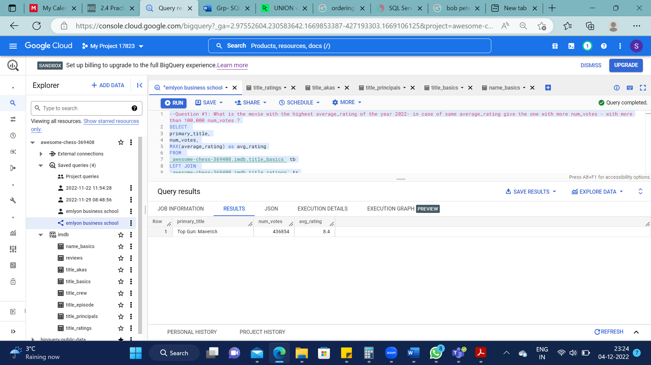

Question #2: In order to have 1 metric to find the best movies, we will use average_rating * num_votes that we will call rating_score - What are the top 5 movies with the highest rating_score ever ?

SELECT

primary_title, (average_rating *num_votes) as rating_score

FROM

`awesome-chess-369408.imdb.title_basics` tb

LEFT JOIN

`awesome-chess-369408.imdb.title_ratings` tr

ON

tr.tconst=tb.tconst

WHERE title_type = 'movie'

ORDER BY rating_score DESC

LIMIT 5

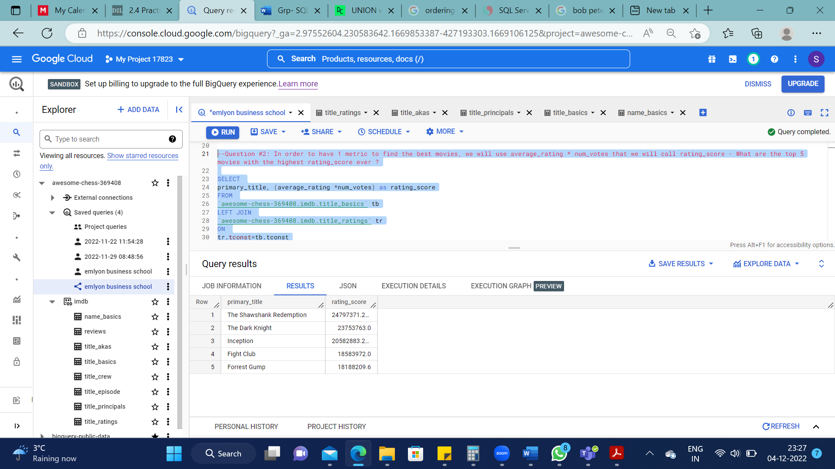

Question #3: Get a query to have for each year, the number of movies released, the highest rating_score for the year and the average of average_rating for the year as well as the sum of num_votes - order by year descending

SELECT

start_year,

COUNT(primary_title) as number_of_movies,

MAX(average_rating *num_votes) as highest_rating_score,

AVG(average_rating) as avg_rating,

SUM(num_votes) as sum_of_votes

FROM

`awesome-chess-369408.imdb.title_basics` tb

JOIN

`awesome-chess-369408.imdb.title_ratings` tr

ON

tr.tconst=tb.tconst

WHERE title_type= 'movie'

GROUP BY start_year

ORDER BY start_year DESC

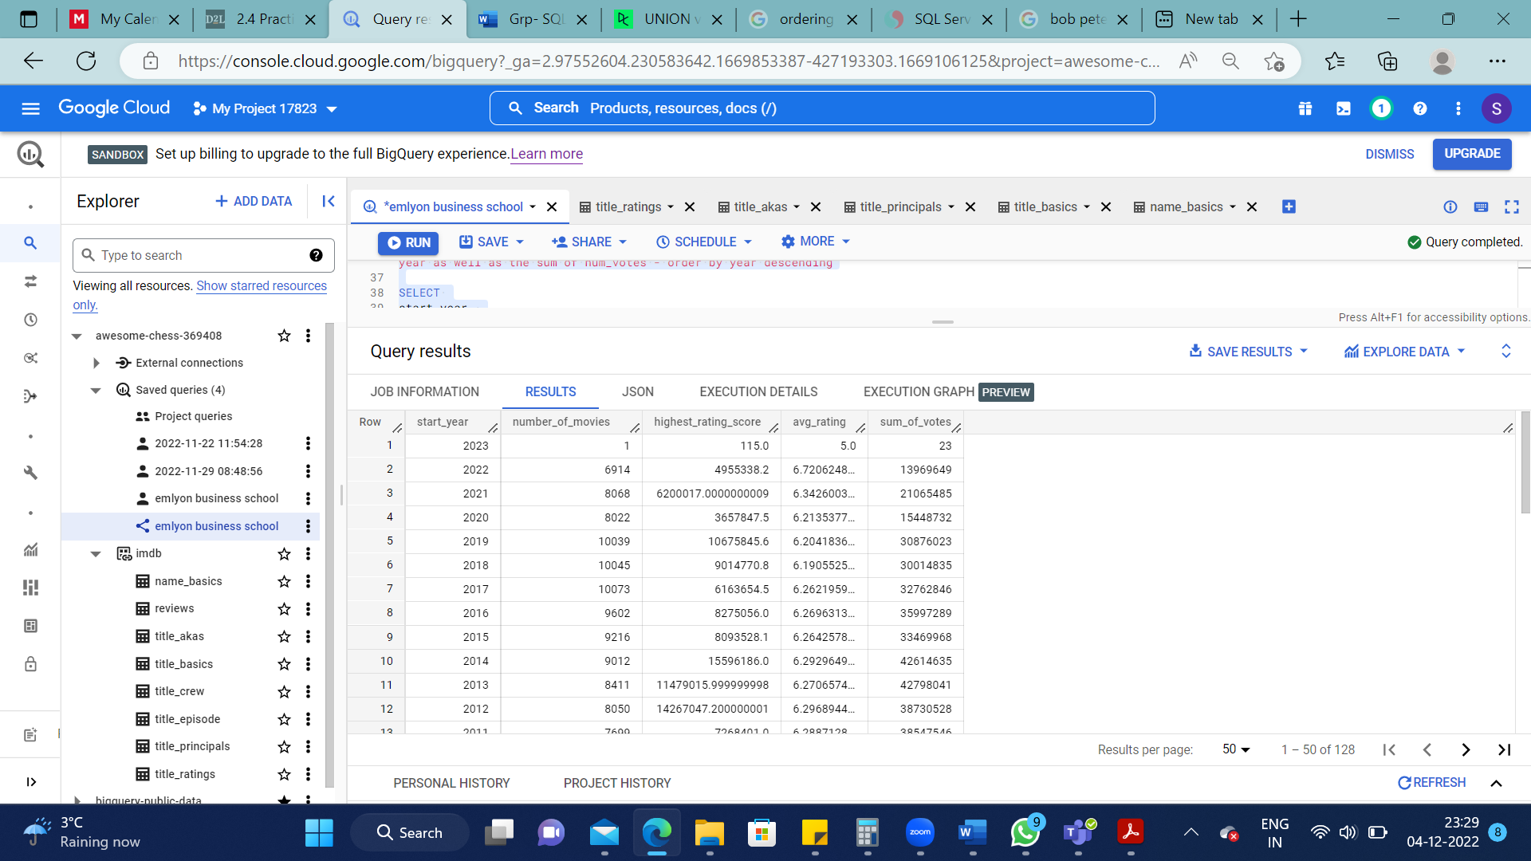

Question #4: Who is the actor who played in movies that has the biggest sum of rating_score - provide also his average of average_rating and his number of movies ??

SELECT

primary_name, COUNT (primary_title) as count_titles, SUM(num_votes*average_rating) as rating_score, AVG(average_rating) as avg_of_avg

FROM

`awesome-chess-369408.imdb.name_basics` nb

JOIN

`awesome-chess-369408.imdb.title_principals` tp

ON

nb.nconst = tp.nconst

JOIN

`awesome-chess-369408.imdb.title_ratings` tr

ON

tp.tconst = tr.tconst

JOIN

`awesome-chess-369408.imdb.title_basics` tb

ON

tb.tconst = tr.tconst

WHERE

category = 'actor'

AND

title_type = 'movie'

GROUP BY primary_name

ORDER BY SUM(num_votes*average_rating) DESC

LIMIT 1

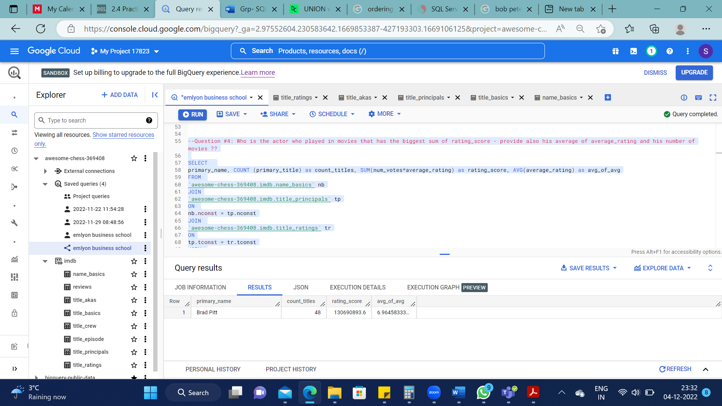

Question #5: What are the top 3 movies with highest rating_score for the actor found above

SELECT

primary_title, (num_votes*average_rating) as rating_score

FROM

`awesome-chess-369408.imdb.name_basics` nb

LEFT JOIN

`awesome-chess-369408.imdb.title_principals` tp

ON

nb.nconst = tp.nconst

LEFT JOIN

`awesome-chess-369408.imdb.title_ratings` tr

ON

tp.tconst = tr.tconst

LEFT JOIN

`awesome-chess-369408.imdb.title_basics` tb

ON

tb.tconst = tr.tconst

WHERE

primary_name = 'Brad Pitt'

AND

title_type = 'movie'

ORDER BY (num_votes*average_rating) DESC

LIMIT 3

--Complex version

SELECT

primary_title

FROM

`awesome-chess-369408.imdb.name_basics` nb

JOIN

`awesome-chess-369408.imdb.title_principals` tp

ON nb.nconst= tp.nconst

JOIN

`awesome-chess-369408.imdb.title_basics` tb

ON tb.tconst = tp.tconst

JOIN

`awesome-chess-369408.imdb.title_ratings` tr

ON tr.tconst = tb.tconst

WHERE

primary_name = (SELECT

primary_name

FROM

`awesome-chess-369408.imdb.name_basics` nb

JOIN

`awesome-chess-369408.imdb.title_principals` tp

ON

nb.nconst = tp.nconst

JOIN

`awesome-chess-369408.imdb.title_ratings` tr

ON

tp.tconst = tr.tconst

JOIN

`awesome-chess-369408.imdb.title_basics` tb

ON

tb.tconst = tr.tconst

WHERE

category = 'actor'

AND

title_type = 'movie'

GROUP BY primary_name

ORDER BY SUM(num_votes*average_rating) DESC

LIMIT 1)

ORDER BY (num_votes*average_rating) DESC

LIMIT 3

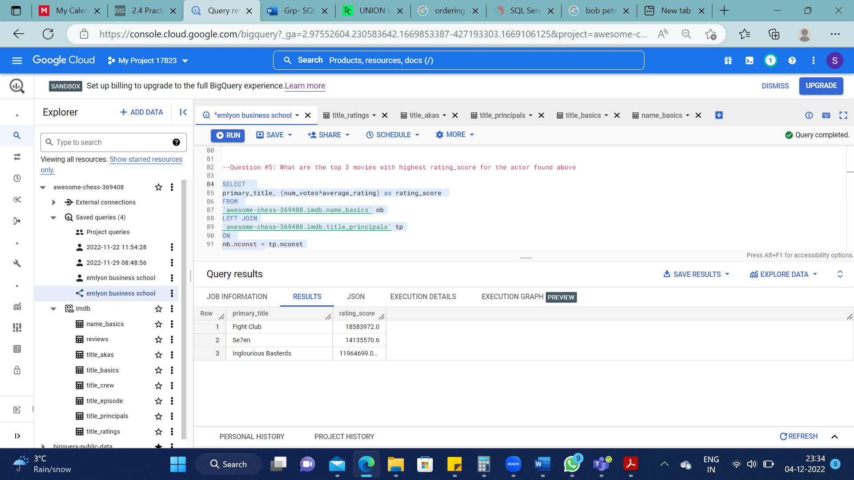

Question #6: Who is the actor who played in at least 5 movies with the highest average rating_score per movie (what is his average rating_score )?

SELECT

primary_name, COUNT(DISTINCT primary_title) AS title_count, AVG(num_votes*average_rating)

AS avg_rating_score

FROM

`awesome-chess-369408.imdb.name_basics` nb

JOIN

`awesome-chess-369408.imdb.title_principals` tp

ON

nb.nconst = tp.nconst

JOIN

`awesome-chess-369408.imdb.title_ratings` tr

ON

tp.tconst = tr.tconst

JOIN

`awesome-chess-369408.imdb.title_basics` tb

ON

tb.tconst = tr.tconst

WHERE

title_type = 'movie'

AND

category = 'actor'

GROUP BY primary_name

HAVING COUNT(DISTINCT(primary_title))>=5

ORDER BY AVG(num_votes*average_rating) DESC

LIMIT 1

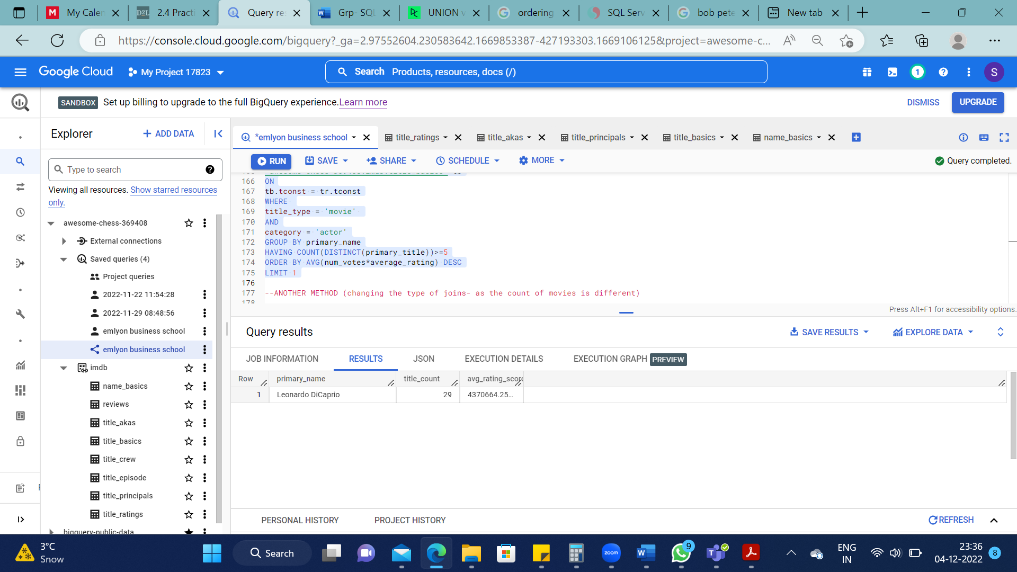

ANOTHER METHOD (changing the type of joins- as the count of movies is different)

SELECT

primary_name, COUNT(DISTINCT primary_title) AS title_count, AVG(num_votes*average_rating) as avg_rating_score

FROM

`awesome-chess-369408.imdb.title_basics` tb

LEFT JOIN

`awesome-chess-369408.imdb.title_principals` tp

ON

tb.tconst = tp.tconst

LEFT JOIN

`awesome-chess-369408.imdb.name_basics` nb

ON

nb.nconst = tp.nconst

LEFT JOIN

`awesome-chess-369408.imdb.title_ratings` tr

ON

tp.tconst = tr.tconst

WHERE

title_type = 'movie'

AND

category = 'actor'

GROUP BY primary_name

HAVING COUNT(primary_title)>=5

ORDER BY AVG(num_votes*average_rating) DESC

LIMIT 1

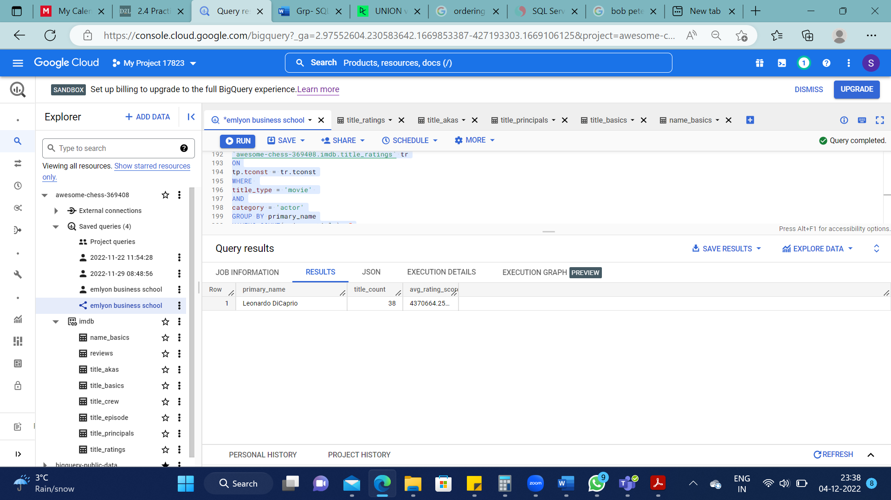

Question #7: Create a Query to get the top movie (highest rating_score) for each year

SELECT

primary_title,

(average_rating*num_votes) AS rating_score,

X.start_year

FROM

`awesome-chess-369408.imdb.title_basics` tb

JOIN

`awesome-chess-369408.imdb.title_ratings` tr

ON tb.tconst = tr.tconst

JOIN

(SELECT

start_year,

MAX(average_rating *num_votes) as highest_rating_score

FROM

`awesome-chess-369408.imdb.title_basics` tb

JOIN

`awesome-chess-369408.imdb.title_ratings` tr

ON

tr.tconst=tb.tconst

WHERE title_type ='movie'

GROUP BY start_year

ORDER BY start_year DESC) X

ON tb.start_year = X.start_year

WHERE

(average_rating*num_votes) = X.highest_rating_score

ORDER BY 3 DESC

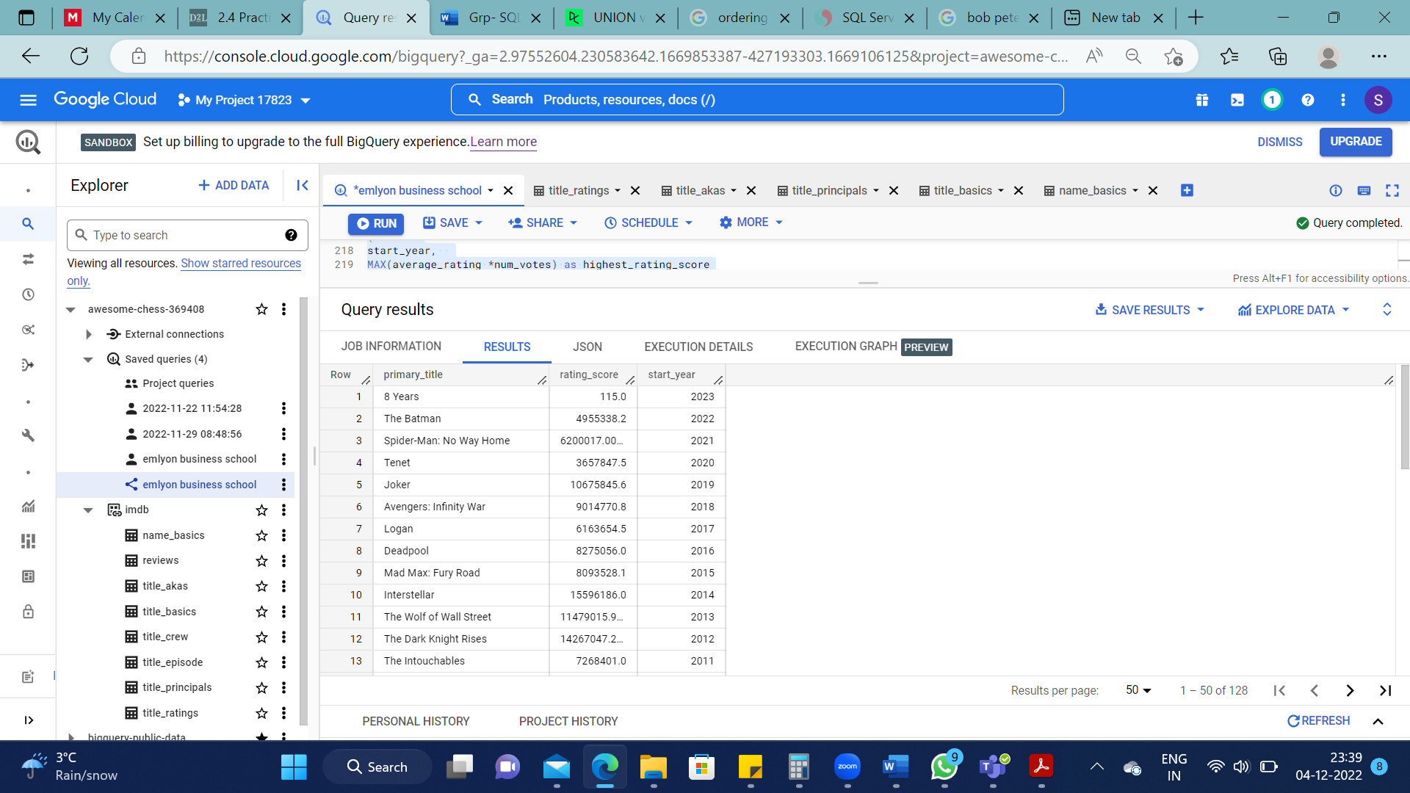

Question #8: For each Movie Genre, for the release since 2000, give the movie title with the highest rating_score

SELECT

tb.genres,

primary_title,

start_year,

(average_rating*num_votes) AS rating_score

FROM

`awesome-chess-369408.imdb.title_basics` tb

LEFT JOIN

`awesome-chess-369408.imdb.title_ratings` tr

ON

tb.tconst=tr.tconst

LEFT JOIN

(SELECT

genres,

MAX(average_rating *num_votes) as highest_rating_score

FROM

`awesome-chess-369408.imdb.title_basics` tb

LEFT JOIN

`awesome-chess-369408.imdb.title_ratings` tr

ON

tr.tconst=tb.tconst

GROUP BY genres

ORDER BY genres) X

ON tb.genres = X.genres

WHERE

(average_rating*num_votes) = X.highest_rating_score

AND

start_year>=2000

AND

title_type = 'movie'

ORDER BY X.highest_rating_score DESC

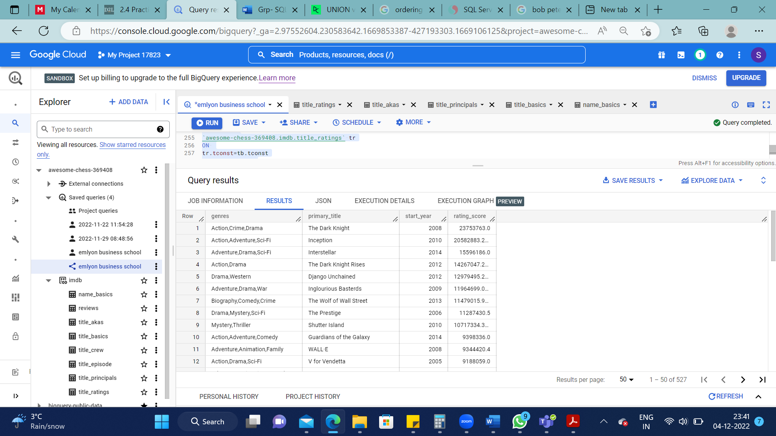

Question #9: Duo? Find the actors duo that get the highest average rating_score per movie together in ordering 1 or 2, with at least 4 movies together

WITH actor_duo AS

(SELECT

primary_name, tb.primary_title, tp.tconst

FROM

`awesome-chess-369408.imdb.name_basics` nb

JOIN

`awesome-chess-369408.imdb.title_principals` tp

ON nb.nconst = tp.nconst

JOIN

`awesome-chess-369408.imdb.title_basics` tb

ON tp.tconst = tb.tconst

WHERE tp.ordering<=2

AND title_type LIKE '%movie%'

AND category = 'actor')

SELECT

ad.primary_name,

ad1.primary_name,

AVG(average_rating*num_votes) AS rating_score,

COUNT(ad.primary_title) AS movie_count

FROM actor_duo ad

JOIN actor_duo ad1

ON ad.primary_name > ad1.primary_name

AND

ad.primary_title = ad1.primary_title

JOIN

`awesome-chess-369408.imdb.title_ratings` tr

ON ad.tconst = tr.tconst

GROUP BY 1,2

HAVING COUNT(ad.primary_title) >=4

ORDER BY rating_score DESC

LIMIT 1

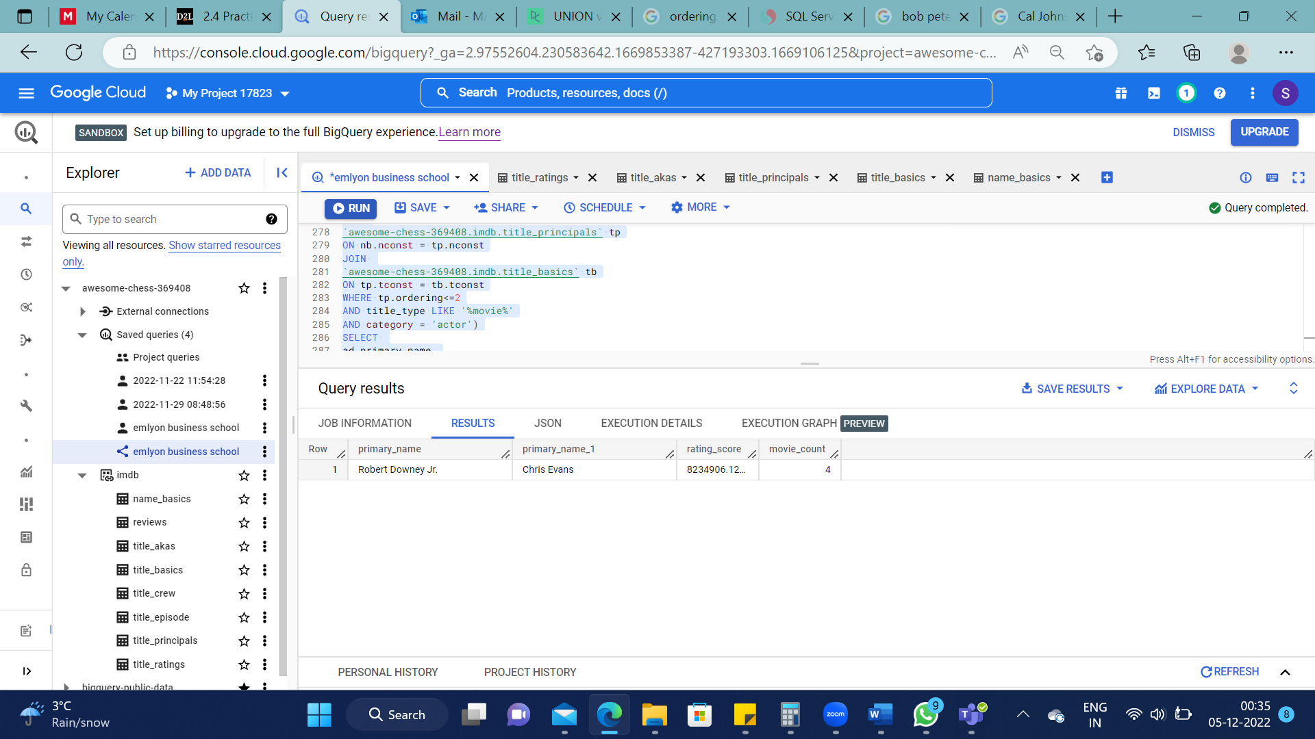

Question #10: Extra - Bonus question if you manage a smart way to show 2 example of their movies together and then to limit the cases where the movies titles very similar looking like they belong to a sequel…

WITH actor_duo AS

(SELECT primary_name,

primary_title

FROM `awesome-chess-369408.imdb.name_basics` nb

JOIN `awesome-chess-369408.imdb.title_principals` tp

ON nb.nconst = tp.nconst

JOIN `awesome-chess-369408.imdb.title_basics` tb

ON tp.tconst = tb.tconst

WHERE

title_type LIKE '%movie%'

AND

category = 'actor')

SELECT

ad.primary_title,

FROM actor_duo ad

JOIN actor_duo ad1

ON ad.primary_title = ad1.primary_title

WHERE

ad.primary_name = 'Robert Downey Jr.'

AND

ad1.primary_name = 'Chris Evans'

AND

ad.primary_title LIKE '%Avengers%'

LIMIT 2

